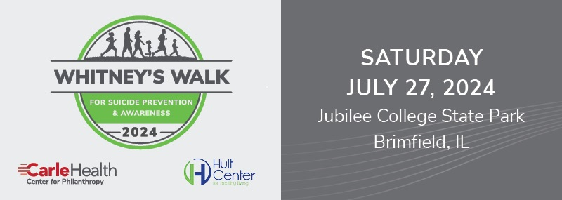

Sponsorship Opportunities

Presenting Sponsor – $10,000
- Logo featured as presenting sponsor on registration materials, tent, event banner, website and participant T-shirts.
- Signage featuring logo along the Whitney’s Walk for Life racecourse.
- Recognition as Presenting Sponsor at event.
- Registration for 10 participants in the walk or race.

Hope for a Better Future Sponsor – $5,000
- Logo prominently displayed on registration materials, event banner, website and participant T-shirts.
- Signage featuring logo along the Whitney’s Walk for Life racecourse.
- Recognition as Hope for a Better Future Sponsor at event.
- Registration for six participants in the walk or race.

Running Toward Awareness Sponsor – $2,500
- Logo on the inside of registration materials, event banner, website and participant T-shirts.
- Signage featuring logo along the Whitney’s Walk for Life racecourse.
- Registration for four participants in the walk or race.

Breaking the Stigma Sponsor – $1,000
- Logo on event banner, website and participant T-shirts.
- Recognition as Breaking the Stigma Sponsor at event.
- Registration for two participants in the walk or race.

Speaking Out for Life Sponsor – $500
- Recognition on participant T-shirts.
- Recognition on day-of event banner.

Sponsorships must be reserved by May 15, 2024, to be included in registration materials.
To ensure inclusion on participant T-shirts, sponsorships must be reserved by June 25, 2024.

